Topic 4: FIRMS AND INDUSTRY
Objectives: At the end of this topic, students should be able to:
- Explain the meaning of a firm. plant and industry
- Give the factors that determines the size of a form
- Concepts of total product (TP). Marginal product (MP). And overage product (OP)
CONTENT:

DEFINITION OF A FIRM
A form may be defined as an independently administered business unit capable of carrying out production and distribution activities.
DEFINITION OF A PLANT
A plant is a physical capital (building and equipment) at a particular location used for the production of goods and services.
DEFINITION OF AN INDUSTRY
An industry is the combination of a number of forms producing broadly similar commodities or services.
CONCEPT OF TOTAL AVERAGE OF MARGINAL PRODUCTION
STEPS TO NOTE
- As TP reaches maximum MP becomes zero
- As TP decreases MP becomes negative

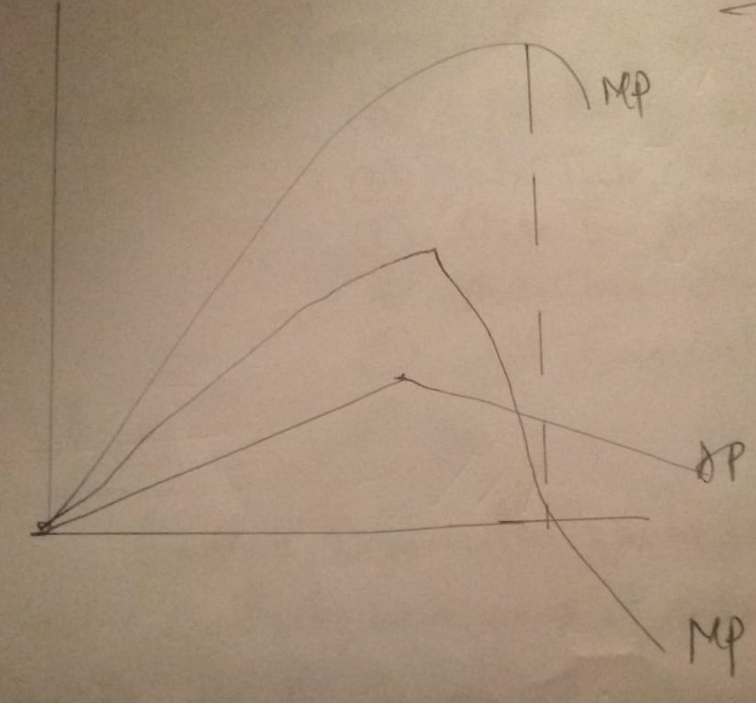
DRILL QUESTIONS
- Explain the following terms and state their formulas
- Total production
- Marginal production
- Average production
- As _______ increases AP and MP increases
- As total production decreases what happens to MP?
- What happens to the total production of the form when MP becomes zero
- Give one advantage of marginal product to a producer

